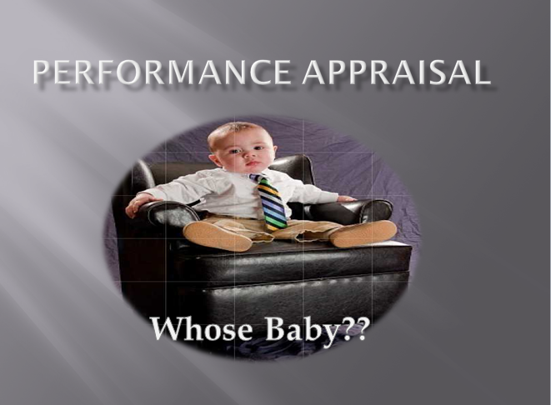
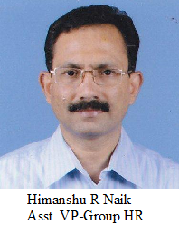
It was definitely Sunday morning in April-1991 but the exact date I don’t recollect.
Arjun, the great warrior was on his target to Pitamaha “Bhishma” & the sharp arrows of Arjun pierced one after another in to the body of Bhishma. Every arrow on hitting the body of Bhishma was being acknowledged by him with a boon, “ayushman bhava…… Vijayi bhava….. yashaswi bhava……”
Breaking my silence, there was a knock at the door, one of the viewers opened the TV room’s door in Officer’s Club House & I also turned around from the television, screening the most popular mythological serial, “The Mahabharat”. The Security guard came inside & handed over a small slip in two folds to me. I opened abruptly & could recognize the handwriting of the PA to the Gen. Manager & read the contents “Mr. Naik, please make it convenient to attend your performance review with the Gen. Manager – Works at 8.00 PM tonight in room no 3, Guest House”. Instantly I felt as if one arrow of Arjun missed the target & pierced in to my chest with a presumption about the kind of appraisal process, I would undergo on Sunday night. I was of course used to the work culture of this Public Sector Undertaking to some extent though I was at the beginning of my career. Un-hesitantly I cursed my immediate boss for leaving the organization which forced me to be appraised by the Unit’s Head directly for the first time.
At about 8.30 PM after 30 minutes wait of heart throbbing moment, my turn came. After a silent pray to “Bajarang bali ji”, the God of Sankat Mochan, I went inside the Room No-3 as if an innocent lamb was going to be slaughtered. GM asked me to occupy a seat in his front. Surprisingly the newly joined Dy. Sales Manager was sitting there.

:: 2 ::
On asking about my achievements, I started from 2% Reduction in absenteeism, completing pending disciplinary proceedings against 23 delinquent employees, setting right the long pending quarter’s allotment problem in workers colony, etc. But I surprisingly observed that my appraiser was concentrating more on a Hindi Film in Television than listening to me. I finished the statement of my achievements and proudly looked at his face for some appreciations. To my surprise he started, “it’s ok, definitely you have done something but these are now past and will discuss on future priorities.” Out of a big list of his expectations, stating a few important funny targets as I recalled, “To demolish a betel shop, built on Government Land but close to the factory’s boundary wall as the workers were gathering there at their shift end time & to him, it was disrupting the discipline of the company, To form another workers’ union to counter the existing recognized union, To recruit near about 100 workers within 15 days to fill up the backward caste quota for immediate compliance of statutory requirements & to save the Management (as Govt.Undertaking) in the ensuing State Assembly’s question answer session’’ . When I expressed my apprehension to achieve these targets within shortest time limit (as most of them were irrational too), the face of my boss turned red. He gave a dirty look & insisted upon me to achieve those at any cost. During discussion on my performance, the Dy. Sales Manager was very much participative as if he was another appraiser to review my performance. Finally I escaped myself from further molestation by my boss as he started concentrating on Ms. Tabu (Hindi Film Heroine), dancing in a romantic scene with the hero in unremembered Hindi film in TV. Like me, Ms. Tabu was also at the beginning of her film career and her dancing style (having worn a nicker) very much mesmerized my boss & he said, “this new heroine definitely has a bright career in Hindi cinema”. To me, thanks God & thanks Ms. Tabu! in specific for saving me as my boss got diverted from such a crushing appraisal discussion to Ms. Tabu’s acting performance. Dy. Sales Manager also grabbed the opportunity to join my boss in discussing on Ms.Tabu’s future in Hind cinema at least to impress the boss with his Cine general knowledge. Along with the end of the film, my appraisal was also concluded with some discouraging notes. The AC in the room could not lessen my sweating and I came out with a big tension, how to recruit near about 100 people within 15 days’ time. Today, recollecting that day’s performance review, one joke comes to my mind instantly which I like to share here.
“In one IT company, It was about the recent attrition rate that was so high. The CEO turned to the manager and told "Hey - take minimum 130 people. Recruit or take some of them from other departments. But complete the work within one month time.
To this, the sweet manager replied " Sir ! Give me one wife and nine months, I shall show you results. Don't give me nine wives and one month. I cannot do anything ." The CEO was not prepared for this answer. Everybody looked at the manager and thought "What an Awesome Reply man!”

:: 3 ::

On that night, coming back from the performance review session to the Officers’ Bachelor Quarter, with a view to get some mental relief, I shared my appraisal experience with my room-mate (A bachelor Chartered Accountant and two years senior to me in service career). I also told him about the performance review process in professional business organizations which I red in the Personnel Management book during my management course. He replied, “boss !, that was theory & this is practical. If you want to survive in Govt. Orgn, only you need to comply with one simple mantra, “Boss is always right”. To please my senior colleague, I nodded.
But I could not sleep till late night, many unanswered questions started banging my mind.

- I was not given sufficient time to prepare myself before attending the review session. Why….?

- My boss did not hear me patiently. He was rather irrationally & rudely demanding. Even I was not given opportunities to share my views & difficulties. I was made a listener only. Why….?

- My achievements were not properly appreciated rather got ignored. Why….?

- I was given targets but unfortunately many of them were very irrational & un-realistic

- My boss was not concentrating on my appraisal discussion rather he was taking much interest to review the performance of a cine heroine , why so…..?

- I was not given proper feed-back on my performance & areas of improvement with proper guidelines to overcome those. Why….?

- Why was the appraisal rating so much confidential in the Govt. undertaking (those days) that I did not know about my performance rating on my achievements?

:: 4 ::

- The place of review was not proper & the review process was frequently disrupted by Television noise. Why was my boss not so serious about a meaningful assessment process? The Dy. Sales Manager, even having no idea about areas of my functions, allowed to interfere and I felt humiliated because of his presence from the beginning of the Appraisal & frequent interference.

- After all I lost a good weekly holiday.
This kind of experience does not end here.
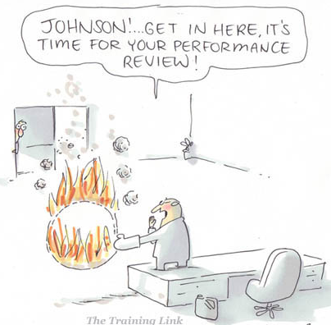
Another boss (unit Head) in my previous (another recent past case) organization had different kind of appraisal technique. He gives sufficient time to subordinate to prepare. He hears patiently & guides to overcome the weak areas in a very demanding mode. He does not allow the review session to get interrupted by even a telephone call to him. He is a very intelligent person & use to go through the Subordinate’s achievement against each KRA in details & prepares a list of important points to be shared with the appraisee during review session one day before. He is an innovative person. He use to come thoroughly prepared to performance review session. Then what is the problem?
Unfortunately he does not believe in the concept of appreciation & recognition of one’s achievement. He is very miser to appreciate & recognize the achievements of his subordinates. Perhaps he strongly believes that his appreciation will unnecessarily boost up the complacency level & will ultimately affect the performance.

:: 5 ::

How does he conduct the performance review?
At the beginning of review process, he welcomes the apprise with very positive notes and encourages the appraise to speak about his achievement against each goal. After hearing about the achievements & self-appreciation from the subordinate, he makes a point, how to undermine every achievement of appraisee & finally concludes the review process with a very discouraging note by saying, “ this target was achieved not because of only your effort rather with support & contribution of your team.” He usually claims, “While it is a team effort, your achievement cannot be rated excellent” even if the appraisee achieved more than the target. Thereafter he very tactfully discusses on non- achievement areas & attributes the subordinate on his non achievements in a much exaggerated manner. Unfortunately he continues the review session for 3 to 4 hours consistently or some times in a phased manner too. At the end of his review, the appraisee use to feel fully exhausted & dehydrated. After coming out of the review session, the appraisee use to feel as if he is responsible for all problems of the company & he is not only accountable for company’s problem rather he is responsible for Kashmir issue, Afghanistan problem, inflation hike in the country & because of his incompetency, these problems remain unresolved. It was most unfortunate that despite being taught about the process of conducting performance review in the in-house workshop, he proudly applies his own techniques to enjoy the frustration of subordinates. However finally due to intervention of Corporate HR, he was forced to amend his style to a great extent but not fully.
An employee joins an organization with a great hope to work, excel, gain and to get recognition. To me, an Appraisal process must aid this belief. Still I have no specific psychological inputs about many bosses in different organizations that why they are so miser in appreciating the strength and contribution of there subordinates loudly.
Definitely the IB has to understand that the objective of performance counseling is to help his subordinate to learn from his senior to further improve his performance. The fearness blocks the path of meaningful interaction between the IB & subordinate. Consequently many problems of the subordinate remain untold and unaddressed which in due course influence the performance adversely. Assessment by the IB & sharing the ratings with appraisee to arrive at mutually agreed ratings, the discussion must focus on quantum of achievement against the expectation, causes of non-achievement, performance gaps & plan for bridging the gaps.
:: 6 ::
I am not the only victim of such kind of appraisal process in the past rather there must be many in their service lives. Who is accountable? The attitude & ego of the boss or weak PMS policy of the organization or lack of ambition of the Top Management for which the people take it just as a formality & a general annual process only which consequently does not create sensitivity among the internal stake holders to sense, “ today we are living in a period of uncertainty and the same strategy, same system, same skill & knowledge level will not work always”.
Why the PMS fails in some organizations.
The answer is very simple that when nobody owns rather feels it’s a burden. The top management lacks it’s business vision & fails to percolate down it’s top priorities to the micro level & fails to foster a performance based culture, the Line Managers prefer to focus on production targets & ignore their people development, other Managers assumes that the concepts of target or goals setting are only limited to production & marketing dept & on the other hand HR does not understand its core responsibility viz to plan, to educate the people & to make the people realize about their responsibilities in PMS process, to monitor the execution & manage the development of the people. Another major reason of failure, when the KRAs of employees are not challenging & not aligned to the Business goals & does not focus on development. Resultantly the people at all levels only concentrate on performance rating at the end of the year instead of performance development. I have seen in the organizations, few of individual KRAs are taken on Innovation, customer satisfaction, People development.

Why do we set the goal?.

The knowledge helps one to reach his destination but one should know his destination. If one does not have a SMART goal in his life he cannot achieve anything even if he is a workaholic. I mean to say, “Specific, Measurable, Achievable, Realistic & Time bound goal” one must have a strong desire to achieve & his desire must be supported by direction, dedication, determination, discipline & deadline.

:: 7 ::

who manages the performance?
The answer is obvious. The performer or the job holder whose performance is being planned, analyzed, assessed & developed. It is he who manages his performance. It is incorrect to say that the primary responsibility for managing the performance lies only with the IB (his boss). The boss is definitely an important instrument in managing the performance as he has the responsibility to ensure that it is defined, planned, analyzed, reviewed, measured & developed.
The large part of PMS responsibility lies with Appraisee, who needs to understand the Organizations top priorities and his departmental goals, which are derived from the organization’s prime goals. Then only he will be able to set his own KRAs which must be aligned to the prime goals of his department and organization. He should ensure that his KRAs must have significant contribution to the organization. Every KRA must have a set of action plan in a documented manner. Why action plan? Because it is a blue print, specifying the resources allocation, schedules & other actions necessary for attaining the goals. Many times there is a confusion with Appraiser & Appraisee about the frequency of appraisal. They adhere to only policy requirement of the organization either quarterly or half yearly. Resultantly it turns into ritualistic Form- filling Exercise. If the object is genuinely Performance Development, the self-appraisal must be a continuous process i.e. at least once in every month by the appraise himself to assess his own performance in term of quantum of achievement, strength & weakness, reason of failure & keeping record of effort put. He will be able to know that whether he is working as per the action plan. If required, he can revise his action plan & he can approach his IB for required support. In my opinion, the P.A is a continuous process of feedback remedial measure throughout the year. Otherwise, the appraisal will be a surprise or shock to employee at the end of year.
Every employee may not have all the capabilities to perform all functions, associated with his role. It is the responsibilities of IB & subordinate to discuss mutually about the reason of poor performance & to identify the capability gap during performance review by looking into subordinate’s functional as well as behavioural dimension. Thereafter the capabilities gap can be bridged through proper training or coaching. The PMS not only develops the performance of employees & organization, it develops a culture of leading a meaningful & successful life in the organization. There is an universal saying, a country or an organization is big not because of its size, because of its people i.e. only “Total Quality People” ---- people with character, commitment, good values & positive attitude. The PMS plays a major role in producing such Quality People. Because it focus on the development of functional as well as behavioural skills.
This is every body’s responsibility right from top management to bottom level people to contribute in developing a performance culture in the organization.

:: 8 ::


To sum up the entire objective this article, I would mention the basic Roles of all stake holders here under in nut shell.
Top Management :
- Vision,Mission & business values of the Organisation are well communicated not only to the internal stake holders but to the external aswell
- The top priorities of a finanacial year are derived from the organizational vision & market forcasting , which are thoroughlly communcated from the top to bottom level of employees
- commitment to devlop a performance based culture in the organisation

HOD :
- making people understanding the vision , mission & top deliverables of the company & imbibing business values in them
- Identifying and setting the annual targets of their respective departments from the top priorities or top deliverables of the organisation & influencing their people to take up challenging KRAs, ultimately contribute in achiving prime goals of the organization
- Commitment of Developing own People with high level of competencies

:: 9 ::

IBs & Employees:
- Setting SMART KRAs for the employee which are linked with top deliverables of the Organization and well understood by the employee.
- Crafting well documented action plan for each KRA
- IB- Reviewing KRAs on regular basis to give honest feedback and to decide theremedial course of Action for Achievement along with his subordinate
- Developmental Plan and Decide coaching and Learning for bridging the capabilities gaps
HR :
- To educate the employees & IBs to propel the PMS religiously & should make it happen in organization
- Educating the IBs how to handle the difficult situation
- Ensuring, continual feedback mechanism is in place
- Play the role of a Driver in establishing a Robust Performance based culture in the Organisation

If the question, PMS, it is whose baby?, the answer is now obvious that the PMS is everybody’s baby. Today you practice & strengthen it and tomorrow it will strengthen you and Ultimately your Organization.



